W1
What is AI?
Systems that think like humans
Systems that act like humans
Systems that think rationally
Systems that act rationally(Doing things that can maximize the expected return)

- What is AI? Why study AI?
  - The scientific understanding of the mechanisms underlying thought and intelligent behavior and their embodiment in machines
  - Search engine, mobile device agent, self-driving car
- What is a performance measure? Rational action? Why are they important for an agent?
- What is the relationship between the agent and task environment? How does the environment affect the agent design?
  - Agent does task in the environment, environment will affect the agent’s performance
  - Agent choose action based on the knowledge it has, environment affects the knowledge that an agent can get
- Why is the boundary between agent and environment important?
  - Agent perceive the environment through the boundary, and make decision based on the info it gets.
- How is this demonstrated by the recent AI successes?
- What is the Turing Test? How has it shaped the field of AI?
  - A machine’s ability to exhibit intelligent behavior equivalent to or indistinguishable from that of a human

- Chapter 1 Problem# 1.14
- Chapter 2 Problem# 2.2, 2.5
- Chapter 3 Problem# 3.9, 3.14
- http://www.aispace.org/search/version4.5.3/launcher.html

agent = architecture + program
an entity that perceives and acts
agent function = it defines how would an agent react on certain circumstance, environment + action, specifies the agent’s action in response to every possible percept sequence
agent program = set of agent functions, combined with a machine architecture, implements an agent function
rationality = doing things that maximizes the outcome of the action
autonomy = don’t need human control, behavior is determined by their own experience rather than solely by their initial programming
reflex agent = choose of action is fully based on the current environment
model-based agent = agent whose action is derived from an internal model of the current world state
goal-based agent = with a goal that will affect how the agent will make choices, an agent that selects actions that it believes will achieve explicitly represented goals
utility-based agent = evaluate the outcome of the action by utility, agent that selects actions that it believes will maximize the expected utility of the outcome state
learning agent = can learn from the info it get from the environment and modify its action based on the knowledge it has

Environment
Fully/Partially observable
Single/Multi agent
Deterministic/Stochastic
Episodic/Sequential
Static/Dynamic
Discrete/Continuous
Known/Unknown

Agent = Architecture + Program

W2
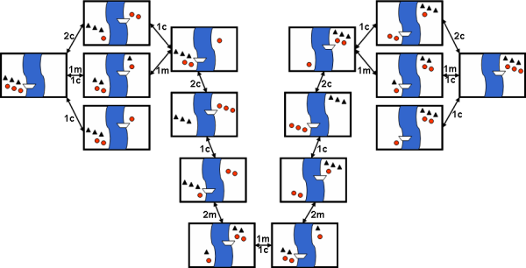
function GRAPH-SEARCH(problem) return a solution or failure
frontier ← MAKE-QUEUE(MAKE-NODE(problem.INITIAL-STATE))
explored_set ← empty
loop do
if EMPTY?(frontier) then return failure
node ← REMOVE-FIRST(frontier)
if problem.GOAL-TEST applied to node.STATE succeeds
then return SOLUTION(node)
explored_set ← INSERT(node, explored_set)
for each new_node in EXPAND(node, problem) do
if NOT(MEMBER?(new_node, frontier)) and
NOT(MEMBER?(new_node, explored_set))
then frontier ← INSERT(new_node, frontier)

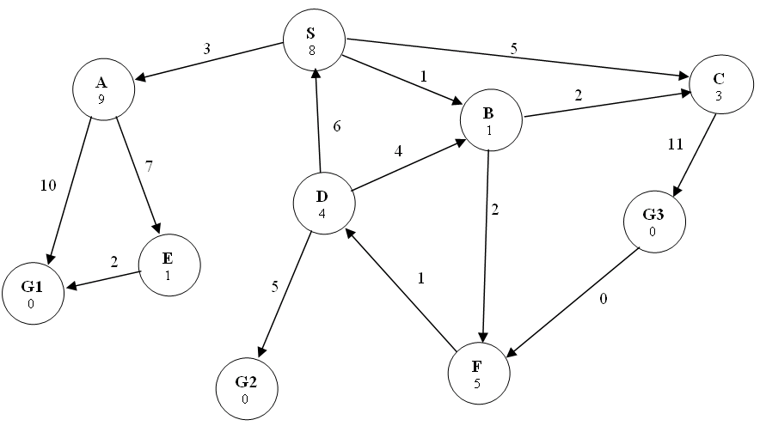
(a) [10%] Depth-first search
Goal state reached: __G1___ States popped off OPEN: _____S_A_E_G1___________

(b) [10%] Uniform cost Search
Goal state reached: ___ G2_ States popped off OPEN: _S_B_ A_C_ F_D_G2________

(c) [10%] A* Search
Goal state reached: ___ G2_ States popped off OPEN: __S_B_ C_ F_D_G2________

- What is the difference between uninformed and
informed search? Which ones are optimal?
- What are the advantages and disadvantages of depth-first search?
- Be familiar with the differences between search strategies shown in Figure 3.21
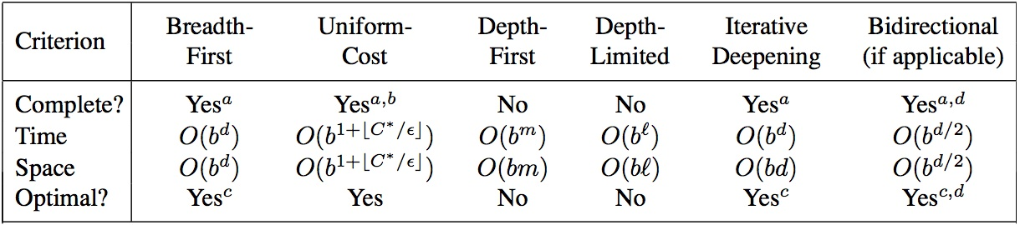

W3
DFS
UCS
A*

a)DFS G1 (2%) _____ SAEG1 ( 8%) [No partial credit]
b)UCS G3(2%) _____ SCDBG3( 8%) [No partial credit]
c)A* G3(2%) _____ SBCDG3 OR SBCDBG3 (8%) [No partial credit]

- Which of the following are true and which are false? Explain your answers.
- Depth-first search always expands at least as many nodes as A∗ search with an admissible heuristic.
- h(n) = 0 is an admissible heuristic for the 8-puzzle.
- A∗ is of no use in robotics because percepts, states, and actions are continuous.
- Breadth-first search is complete even if zero step costs are allowed.
- Assume that a rook can move on a chessboard any number of squares in a straight line, vertically or horizontally, but cannot jump over other pieces. Manhattan distance is an admissible heuristic for the problem of moving the rook from square A to square B in the smallest number of moves.

False: a lucky DFS might expand exactly d nodes to reach the goal. A∗ largely dominates any graph-search algorithm that is guaranteed to find optimal solutions.
True: h(n) = 0 is always an admissible heuristic, since costs are nonnegative.
False: A* search is often used in robotics; the space can be discretized or skeletonized.
True: depth of the solution matters for breadth-first search, not cost.
False: a rook can move across the board in move one, although the Manhattan distance
from start to finish is 8.

- What is the difference between uninformed
and informed search? Which ones are optimal?
- What are the advantages and disadvantages of depth-first search?
- Why does a search heuristic need to be “admissible”?
- Be familiar with the differences between search strategies shown in Figure 3.21, and also all informed search
Chapter 4: # 4.1
Chapter 6: # 6.1, 6.5

Greedy BFS: not opt
A*: opt if admissible consist

DFS less space, not complete not opt

Not admissible heuristic can come to solutions not opt

W4 Beyond classical search
Hill climbing: not com, not op, time, space
Local beam search, not com, not op
Simulated annealing, not, not
Genetic algorithm, not , not
Adversarial search
Minimax
Alpha-beta pruning
- What are the characteristics of local search? Is it complete? Optimal? Time and Space complexity? Not worry about path to sol
- What problem domains are well-suited to each type of search technique? Ill-suited? Why?
  - Hill: densely packed goal
  - Simulated Annealing
  - Local beam
  - Genetic search
- Know how to compare their performance in general and in a specific domain or problem.
- What are the characteristics of Adversarial Search? Why is meta-reasoning important in this type of search?
Give the name of the algorithm that results from each of the following special cases:
- Local beam search with k = 1.
- Local beam search with one initial state and no limit on the number of states retained.
- Simulated annealing with T = 0 at all times (and omitting the termination test).
- Simulated annealing with T = ∞ at all times.
- Genetic algorithm with population size N = 1.
Hill climbing
BFS
Hill climbing
Random walk
Random walk

W5
- What is the Turing Test? How has it shaped the field of AI?
- What does it mean that a search algorithm is complete? optimal? Why do we care about these criteria?
- Why do we study the complexity of an algorithm?
- What is the difference between time and space complexity?
- How does complexity affect the Turing Test?

- What is the difference between uninformed and
informed search? Which ones are optimal?
- What are the advantages and disadvantages of depth-first search?
- Why does a search heuristic need to be “admissible”?
- Be familiar with the differences between search strategies shown in Figure 3.21
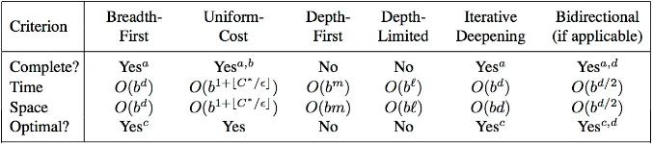
- What are the characteristics of local search? Is it complete? Optimal? Time and Space complexity?
- What problem domains are well-suited to each type of search technique? Ill-suited? Why?
- Know how to compare their performance in general and in a specific domain or problem.
- What are the characteristics of Adversarial Search? Why is meta-reasoning important in this type of search?

- General AI
- Search Concepts
- Comparing Strategies
- Game playing
- CSP
- AI Applications

- ____ The Turing test defines the conditions under which a machine can be said to be “intelligent”.
- ____ A* is an admissible algorithm.
- ____ DFS is faster than BFS.
- ____ DFS has lower asymptotic space complexity than BFS.
- ____ When using the correct temperature decrease schedule, simulated annealing is guaranteed to find the global optimum in finite time.

FFFTF

- ____ Alpha-beta pruning accelerates game playing at the cost of being an approximation to full minimax.
- ____ Hill-climbing is an entirely deterministic algorithm.
- ____ The exact evaluation function values do not affect minimax decision as long as the ordering of these values is maintained.
- ____ A perfectly rational backgammon-playing agent never loses
- ____ Hill climbing search is best used for problem domains with densely packed goals

FFTFT

Suboptimal solution (long path) Optimal solution
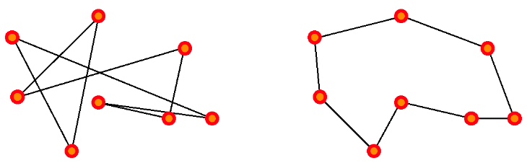
- A suitable representation for states:
- The initial state of the problem:
- A good goal test to use in this problem:
- Good operators to use for search:
- Which search algorithm would be the most appropriate to use here if we want to minimize the distance of the tour found?

permutation of all cities in the tour
<A, B, C, D, E>
random permutation of all cities
minimize the distance travelled
permute 2 cities
Local Search - GA/SA/hill climbing, etc…
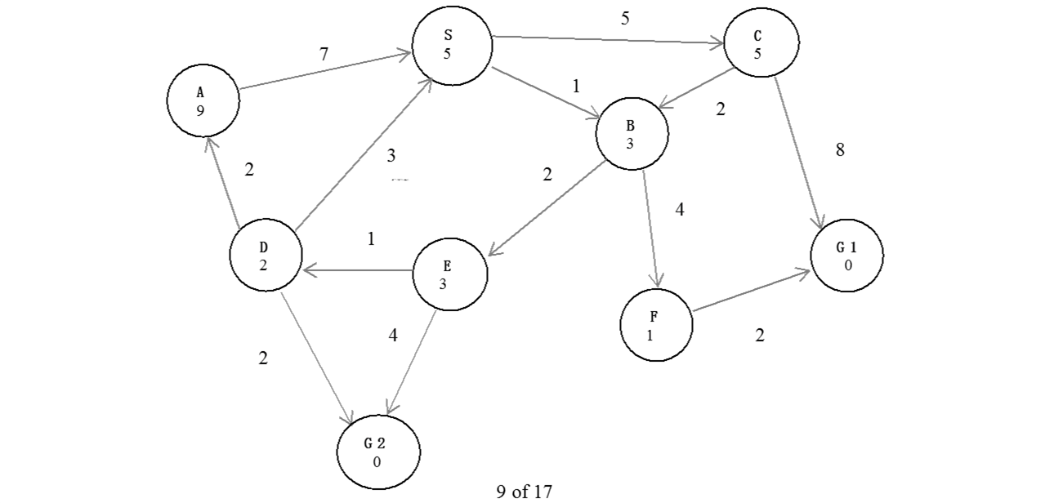
Greedy: S , B , F , G1 Goal: G1
Ucs:S , B , E , D , C , F , A , G2 Goal : G2
Ids iterative deepening search:S , S , B , C , S , B , E , F , C , G1 Goal: G1
A*:S , B , E , D , F , G2 Goal: G2

b) O , I, T , U , Y
c) Yes, the best order will be D , B , C .
Pruned nodes will be : Y , F , N , O , I , T , U

The schedules of the customers are:
Company 1: Webflix: 8:00-9:00am
Company 2: Anazon: 8:30-9:30am
Company 3: Pied Piper: 9:00-10:00am
Company 4: Hooli: 9:00-10:00am
Company 5: Gulu: 9:30-10:30am
- Using Company as variable, formulate this problem as a CSP problem with variables, domains, and constraints. Constraints should be specified formally and precisely, but may be implicit rather than explicit.
- Draw the constraint graph associated with your CSP.
- Show the domains of the variables after running arc-consistency on this initial graph (after having already enforced any unary constraints).
- Give one solution to this CSP.

The schedules of the customers are:
Company 1: Webflix: 8:00-9:00am
Company 2: Anazon: 8:30-9:30am
Company 3: Pied Piper: 9:00-10:00am
Company 4: Hooli: 9:00-10:00am
Company 5: Gulu: 9:30-10:30am
- Using Company as variable, formulate this problem as a CSP problem with variables, domains, and constraints. Constraints should be specified formally and precisely, but may be implicit rather than explicit.
- Draw the constraint graph associated with your CSP.

- Which AI application has a discrete, static environment?
  - Robocup Soccer robots
  - Google Self-driving car
  - IBM’s Deep Blue
  - All of the above
  - None of the above
- Using local search is the preferred method to find a solution for the problem of assigning seats during an exam for N students in a room with N rows of N columns of chairs, where no two students can sit in the same row, column or diagonal, because:
  - Local search is always the preferred search method for CSP
  - There are no local minima or maxima in this problem domain
  - This problem domain has densely packed goals
  - All of the above
  - None of the above
- Though none of these AI applications have passed the Turing test, which is considered rational?
  - Robocup soccer robots
  - Google Maps
  - IBM’s Deep Blue
  - All of the above
  - None of the above
- An admissible heuristic for route planning in Google Maps could be?
  - Straight-line distance
  - Manhattan distance
  - h(n)=1
  - All of the above
  - None of the above

CCDA

